Expository Writing (SL1014)
Date: 6th April (Monday) 2026
Course Instructor
Abdul Basit Khan
Assignment # 3
Total Time (Hrs.): | 1
Total Marks: | 10
Total Questions: | 1

25P-0005 BAI-2A Waleeja Khan
Roll No Section Student Signature

CLO 3: Apply constructive peer feedback, critical reading strategies, and reflective practices to evaluate and improve written and oral communication tasks.

Q#1. The pie graphs below show the result of a survey of children's activities. The first graph shows the cultural and leisure activities that boys participate in, whereas the second graph shows the activities in which the girls participate. Write a report describing the information shown in the two pie graphs. Write at least 150 words.
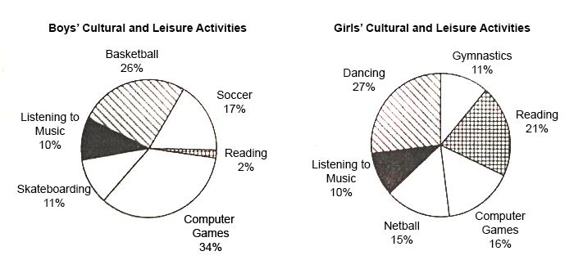

REPORT ON CHILDREN’S CULTURAL AND LEISURE ACTIVITIES:

According to the pie charts, a general comparison among boys’ and girls’ interests is that boys prefer physical activities and online games, while girls show more balanced interests like cultural activities and book reading.
The survey report highlights that boys mostly take part in computer-based games, about 34%. Other than that, they take part in physical activities like basketball at about 26%, soccer about 17% and skateboarding about 11%. Listening to music is considered as a moderate choice of about 10%, while book reading is seen as least interesting activity for boys and is at about 2%.
For girls, the interests are balanced and participation in all activities is almost at same level. Dancing is most popular among girls and is at 27%, while in contrast to boys, reading books is at a higher-level interest at about 21%. Computer games and netballs are at minimal level of about 16% and 15%. Other than that, gymnastics at 11% and listening to music 10% shows balanced level of interest among girls.
A key comparison is that boys spend more time on games and are less interested in reading, while girls’ interest is evenly distributed and they take more part in reading compared to boys.
The survey highlights clear differences between boys’ and girls’ interest, showing boys more participation in physical activities while girls more participation in creative work.

Plagiarism will be checked.

